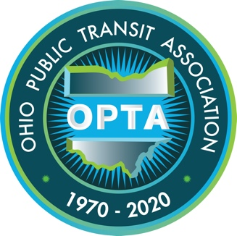
Type your text here
Ohio Public Transit Association
600 North High Street #175 | Columbus, Ohio 43215

614.595.6919 | admin@ohioneedstransit.org

