LOGOS – Delete the red copy in left column
- Insert your system logo

FOR IMMEDIATE RELEASE

OPTA Launches Ride Easy Ohio Statewide Campaign

Insert Date, City, State – Safety remains a top priority for public transportation providers. As such, the Ohio Public Transit Association (OPTA) today is launching Ride Easy Ohio, a campaign highlighting safety initiatives to maintain public transportation as a safe and viable option during the COVID-19 pandemic.

Throughout the state of Ohio, transit systems are taking significant steps to help prevent the spread of COVID-19. Best practices include wearing facial coverings, practicing social distancing when possible, cleaning and sanitizing vehicles and facilities, practicing safe hygiene, and employee self-monitoring. In addition, transit systems are working closely with local and state health agencies to develop policies and procedures in conjunction with guidelines issued by governing municipalities.

[Insert quote from System Leadership]

OPTA recognizes the vital role public transit has played during the pandemic. Ohioans can ride easy knowing public transit systems will continue prioritizing the safety and well-being of passengers and employees.

For more information about Ride Easy Ohio,
visit Ohio Needs Transit Ride Easy Ohio

OPTA is the primary advocate for public transportation in Ohio. The association provides leadership, resources, training, support, technical assistance, media outreach, public engagement, and governmental relations services to public and private transit agencies and businesses across the state.

For more information, contact
Insert contact information

Insert system name, address, phone

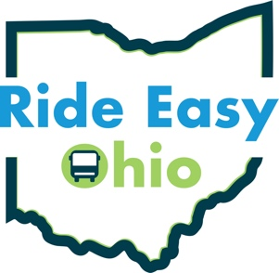
Ride Easy Ohio
in partnership with:

Delete this copy and insert your logo here.
