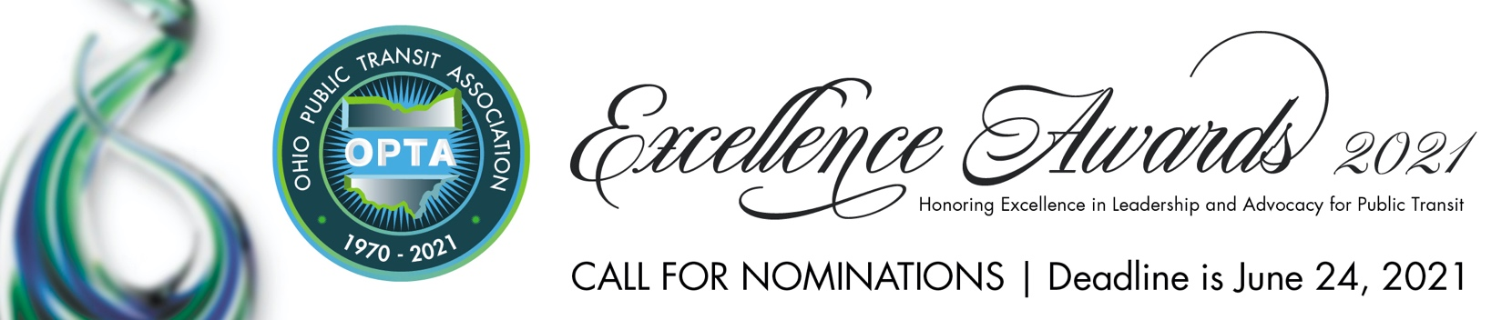

The OPTA Awards Committee is seeking nominations for the OPTA Excellence Awards 2021 to be presented on Friday, September 17 during the OPTA Excellence Awards luncheon.

The Excellence Awards luncheon will be hosted on Friday, September 17 in conjunction with the Ohio Needs Transit Conference & OPTA EXPO 2021 which will be held at the John S. Knight Center, Akron, Ohio.

The past year provided unprecedented challenges to all who work within public transit as well as those stakeholders that support the industry.

We encourage the leadership of Ohio’s transit systems to take the time to honor individuals who have demonstrated themselves to be role models and leaders in public transit.

    - Award nominations should include recognition of work during the 2020 calendar year.
    - Award nominations must be submitted on or before Thursday, June 24, 5:00 pm.
    - Awards may be submitted using this form or on a separate document.
    - Award Nomination can include multiple recipients.
    - If you are submitting in more than one category, separate nomination forms must be submitted.
    - Submissions must be fully complete and include facts and statistics in telling the story of the nominee’s achievements.
- Additional materials such as photos and media articles can be submitted with the nomination form.
    - Recipients will be informed and announced on or before August 1, 2021.
    - Recipient will receive a complimentary pass to the Ohio Needs Transit Conference & OPTA EXPO 2021.

Return Nomination Form to:
Julia Schick, Chair, OPTA Excellence Awards 2021 | jschick@laketran.com

For More Information Contact: Julia Schick | jschick@laketran.com | 440.350.1012

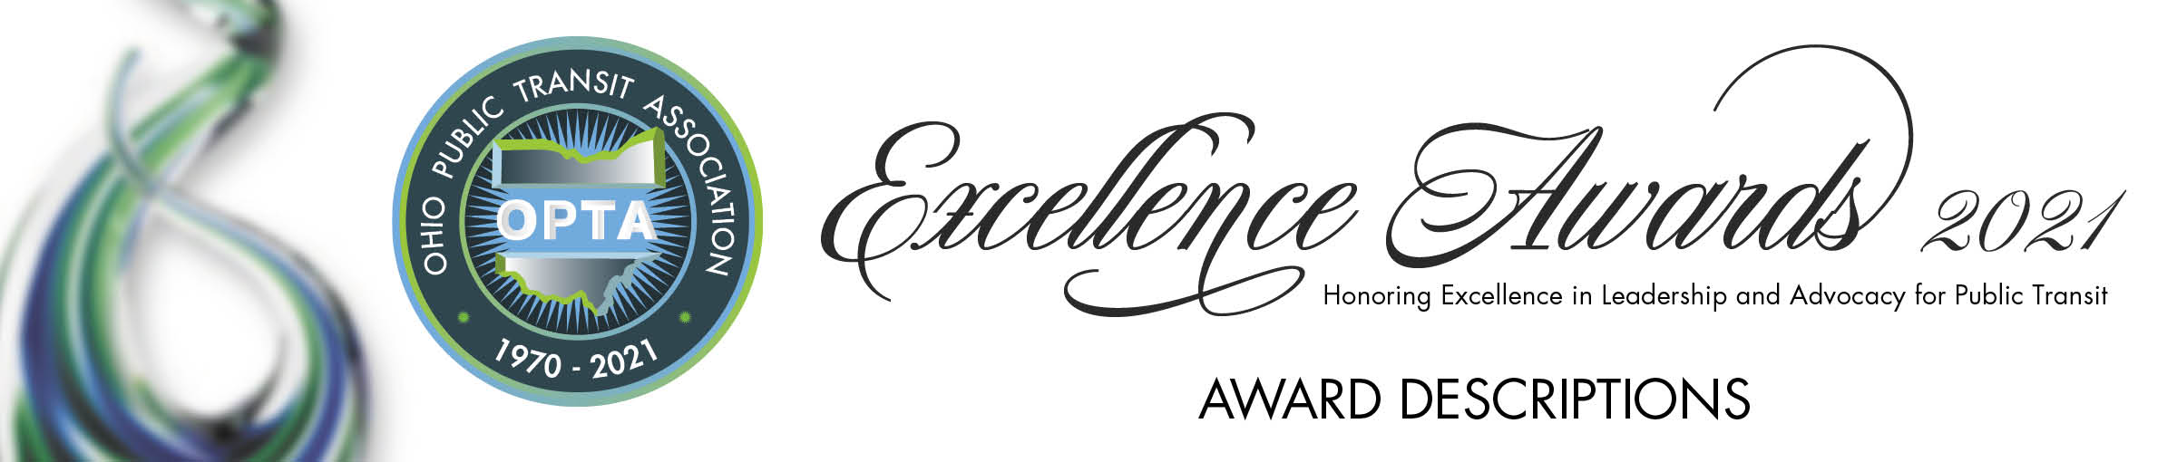

Leonard Ronis Award Awarded to one recipient for noteworthy accomplishments in the field of public transit.

Mobility Manager Awarded to a Mobility Manager whose advocacy, innovative collaborative efforts and dedicated public service best represents the spirit and professionalism of mobility management.

Legislator of the Year Awarded to one elected official who has advanced the improvement of public transit statewide.

Four Under Forty Awarded to transit professionals and stakeholders under the age of 40 to
celebrate the future of transit in Ohio. Nominations will be judged based upon achievement in transit and leadership within their specific communities.

Milestone Award Award recognizes individuals or transit agencies reaching significant
milestones in the transit industry.

Milestones can be very diverse and could include an individual who has given a significant number of years of service or has implemented a system-wide program that has had a major impact.

Associate Engagement Award recognizes the contribution of OPTA’s Associate Member through their overall engagement, membership and participation in transit programs and business or other contributions that helped to advance public transit.

This recipient can be an individual, a business/organization or both.

Collaborative Excellence Award The OPTA Collaborative Excellence award recognizes a program, business, academic institution or individual which has demonstrated an exemplary partnership or an innovative collaboration within the public transit industry for a sustained period of three months or more.

Community Impact Award Awarded to any transit employee who has had a significant impact within
a community. Examples include, but not limited to, a heroic act while in the line of duty or organizing an employee food drive for less fortunate individuals.

Lifetime Achievement Awarded to one recipient for noteworthy accomplishments in the field of public transit.

For more information, contact
Phyllis VanArsdale, Executive Administrator
Ohio Public Transit Association
pvanarsdale@ohioneedstransit.org | 614.595.6919

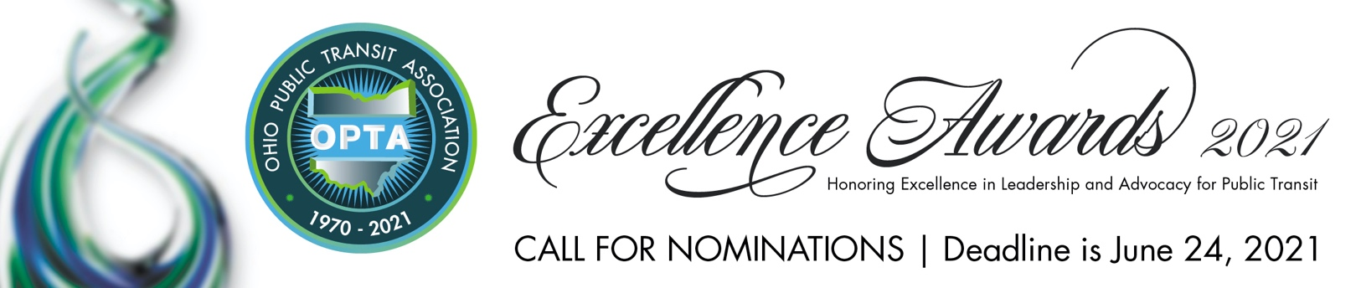

Return Nomination Form to: Julia Schick, Chair, OPTA Excellence Awards 2021 | jschick@laketran.com

AWARD

Nominator Contact Information:
Name
Title
Organization
Email
Phone

Nominee Contact Information:
Name
Title
Organization
Email
Phone

Additional Nominees:
Name
Title
Organization
Email
Phone

Name
Title
Organization
Email
Phone

Nomination form continues on next page.

Why is your nominee deserving of the above award?

